Department of Computer Science & Engineering
Final Year B. Tech. (CSE) – I: 2022-23 5CS462: PE5 - Data Mining Lab

Assignment No. 9 : Mini Project

PRN: 2020BTECS00205
NAME: Monika .V. Chitrakathi
BATCH: B8

Title: 16] Predicting Stock Prices with Neural Networks
Use a neural network to predict stock prices. Download the data from Yahoo! Finance and then train neural network to predict future stock prices.

Objective/Aim:
  - To implement data analysis tool using python programming language.
  - The initial data we will use for this model is taken directly from the Yahoo Finance page
  - To Training and validating data,data normalization,creation of deep learning model LSTM.

Introduction:

Predicting stock prices is a cumbersome task as it does not follow any specific pattern. Changes in the stock prices are purely based on supply and demand during a period of time. In order to learn the specific characteristics of a stock price, we can use deep learning to identify these patterns through machine learning. One of the most well-known networks for series forecasting is LSTM (long short-term memory) which is a Recurrent Neural Network (RNN) that is able to remember information over a long period of time, thus making them extremely useful for predicting stock prices. RNNs are well-suited to time series data and they are able to process the data step-by-step, maintaining an internal state where they cache the information they have seen so far in a summarised version. The successful prediction of a stock's future price could yyield a significant profit.

Theory:
From last few years there have been many up’s and downs in stock market, as there are n factors which can affects a share market. Thus, due to its dynamic nature, it is very highly difficult to predict a stock price. To address this issue there should be some system which can detect the pattern in stock prices when influenced by political, economic and natural environment as well as which can take what are the people’s sentiment about the particular company. In this paper, authors have presented a possible mixture of sentiment analysis and historical stock price. Now one of the major concerns before predicting the stock prices is to use the reliable historic stock data, thus pre-processing of data is also must.

Functional Block Diagram:

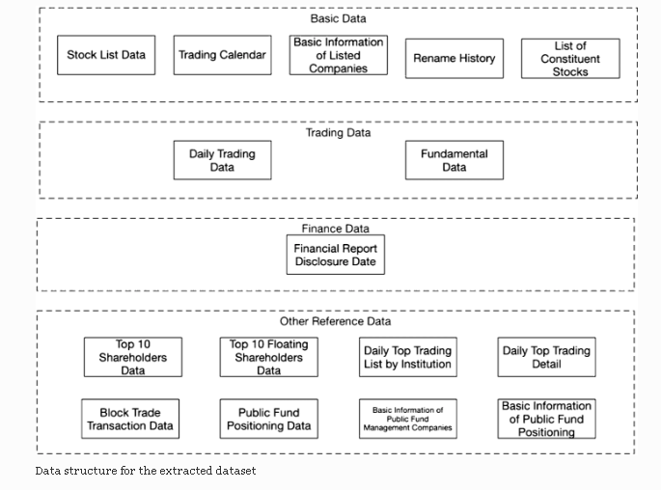

Procedure:
Given problem statement is solved using python programming language and Deep neural network.Created deep learning model LSTM.

Screenshots:

